OFFICE OF THE ATWIMA KWANWOMA DISTRICT ASSEMBLY

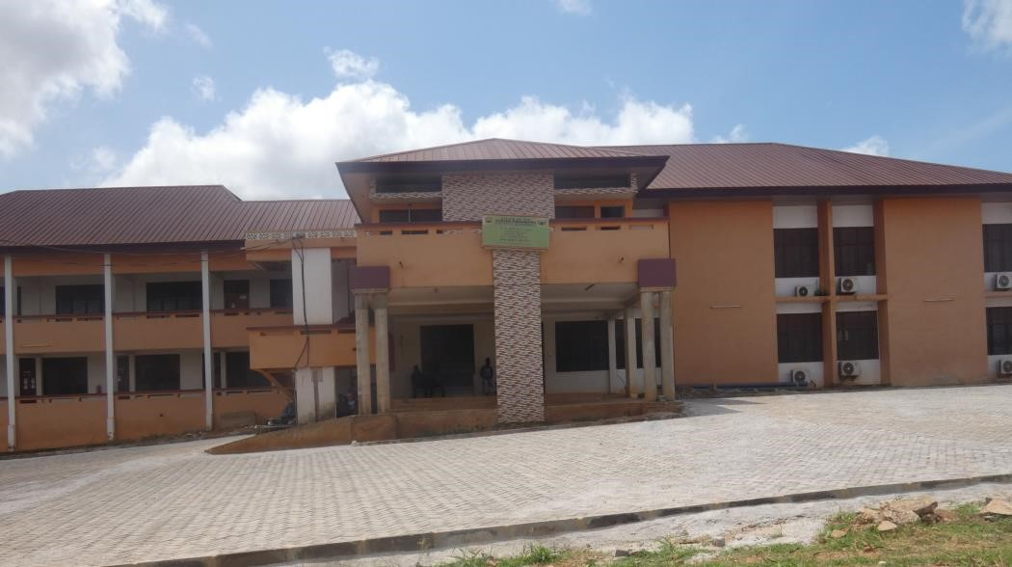

CLIENT SERVICE CHARTER

PREPARED BY:

THE DISTRICT PLANNNG COORDINATING UNIT
(DPCU)

JANUARY
2025

CLIENT SERVICE CHARTER
ATWIMA KWANWOMA DISTRICT ASSEMBLY
TWEDIE

1.0 INTRODUCTION
We are the Atwima Kwanwoma District Assembly (AKDA) created by LI 2253 under the Ministry of Local Government, Decentralization and Rural Development (MLGDRD) of the Republic of Ghana. Our area of jurisdiction includes:

Twedie, Foase, Bebu, Trede, Kwanwoma, Konkoli , Nkoranza, Brofoyedru and others. We also share common boundaries with the Atwima Nwabiagya Municipal Assembly to the West, the Kumasi Metropolitan to the North, Bekwai Municipal to the South and Bosomtwe District to the East.

2.0 VISION
To become a highly professional socio-economic development service provider, which creates opportunities for human resources development with traditional authorities and non-state actors in the District.

3.0 MISSION
To facilitate improvement in the quality of life of the people in the District through the provision of basic social amenities and services and the promotion of socio-economic development within the context of governance.

4.0 CORE VALUES
Our core values include
- Professionalism
- Efficiency and Effectiveness
- Client Focus
- Accountability and Others

5.0 FUNCTIONS
The functions of the Assembly as given in the Local Governance Act, 2016 (Act 936) are as follows:
- Be responsible for the overall development of the District
- Formulate and execute plans, Programmes and strategies for effective, mobilization of resources for the overall development of the district
- Promote and support productive activity and social development in the district and remove any obstacles to initiative and development
- Initiate programmes for the development of basic infrastructure and provide municipal works and services in the district
- Be responsible for the development, improvement and management of human settlements and the environment in the district
- Collaborate with the relevant national and local security agencies to maintain security and public safety
- Promote justice by ensuring ready access to courts

Section 12 sub-section 4 Act 936 also mandate the District Assembly to:
- Execute approved development plans for the District.
- Guide, encourage and support the Sub-District local structures, public agencies and local communities to perform their functions in the execution of approved development plans.
- Initiate and encourage joint participation with other persons or bodies to undertake projects under approved development plans.
- Monitor the execution of projects under approved development plans and assess and evaluate their impact on the development of the District and national economy in accordance with government policy.

6.0 LEGAL PROVISIONS AND GUIDELINES
The Atwima Kwanwoma District Assembly operate with the following legal provisions and guidelines:
- The 1992 Constitution of the Republic of Ghana
- Local Governance Act, 2016 (Act 936)
- Public Financial Management Act, 2016 (Act921)
- Public Procurement Act, 2016 (Act 941)
- Spatial Planning Act, 2016 (Act 925)
- National Development Planning (System) Regulations, 2016 (L.I 2232)
- Composite Budget Guidelines, 2018
- Public Law, 2012 (Act, 851)
- Mental Health Act, 2012 (Act, 846)
- Gazzetted Bye Law
- The Section 296 Of Criminal Offence Act, 1960 (act, 29) in respect of stray animals.
- The Auction Sales Act, 1989 (PNDC Law 230)
- The Liquor Licensing Act, 1970 (Act, 331)
- The Control and Prevention of Bush Fires Act, 1990 (PNDC Law 229)
- The Section 296 of Criminal Offence Act, 1960 (Act 29) in respect of littering.

7.0 OBJECTIVES OF THE ASSEMBLY
The Atwima Kwanwoma District Assembly is the highest political and administrative body of the District and therefore exercises Deliberative, Legislative and Executive functions. It has the mission and responsibility to improve the quality of life of the people through sustainable development. To achieve this mission, the Assembly has set the following objectives:
- To facilitate the effective functioning of the Local Government institutions in District.
- To ensure efficiency and effectiveness in the mobilization and utilization of Resources in the District Assembly and its decentralized departments.  To monitor, co-ordinate and harmonize the implementation of development plans and activities in the District Assembly.
- To facilitate the provision of basic social and economic infrastructure and services in the District.
- To facilitate community-based and private sector development in the
District.

8.0 DEPARTMENTS OF THE DISTRICT ASSEMBLY
Section 78 of the Local Governance Acts 2016 (Act 936) specify Department of the District Assembly as follows:
- Central Administration Department
- Finance Department
- Education, Youth and Sport Department
- District Health Department
- Agriculture Department
- Physical Planning Department
- Social Welfare and Community Development Department
- Works Department
- Trade and Industry Department
- Natural Resources, Forestry Conservation and Game Wildlife Department
- Disaster Prevention Department1
- Department of Agriculture
- Department of Statistics
- Department of Human Resources
- Department of Birth and Death
- Department of Housing

9.0 WE ARE RESPONSIBLE FOR:

    - Issuance of Building permit
    - Birth and death registration
    - Insurance of Business Operating License
    - Approval of Planning Schemes/ layouts
    - Development Control physical development of settlements
    - Waste Management (Liquid and Solid)
    - Revenue mobilization
    - Fixing of rates/tolls
    - Provision of basic socio-economic infrastructure, including schools, markets, lorry parks, institutional toilets and roads
    - Facilitate the provision of water and electricity
    - Maintenance of peace and security
    - Sports development

10. SERVICE STANDARDS OF THE ATWIMA KWANWOMA DISTRICT ASSEMBLY

We shall issue certificates and provide other services within the following time frames:
 | SERVICES |  | TIME FRAME (MONTHS/DAYS)
● | Issuance of building permits | ● | Within two (2) month or 48 days
● | Preparation and approval of planning schemes/layouts | ● | Within six (6) month on (1) year depending on the size of the settlement
● | Building  inspection/Development Control | ● | daily
● | Issuance of Business Operating  Permit (BOP) | ● | Within three (3) working days
● | Issuance of Birth Certificate | ● | Under 1yr (1day)
 |  | ● | Above 1yr (2 weeks)
● | Issuance of Death Certificate | ● | Fresh Death (1day)
 |  | ● | Already buried (3weeks)
● | Waste management  (door-to-door collection) | ● | Once every week
● | Issuance of food vendors  certificate | ● | Instant
● | Public education on hygiene practice | ● | Daily
● | In case a permit is refused | ● | Applicant will be notified within one week and reasons stated

● | In case a contract is refused | ● | The bidder will be notified within one week and reasons stated
● | Inspection of canned foods | ● | weekly
● | market/house inspection | ● | Daily
● | Registration of drivers union | ● | Acquisition of certificate within a day
● | Preparation of tender documents | ● | Two (2) week
● | Advertisement of Assembly projects for contract | ● | Two (2) weeks
● | Respond to correspondences | ● | Within three (3) days
● | Dispatching of official letters | ● | Within a day
● | Tender opening | ● | Two (2) weeks  advertisement | after
● | Tender committee meeting | ● | Two weeks’ notice
● | Notification of award | ● | Within a week
●   | Receipts of complaints, reports, petitions from the general public  Preparation of Annual  Procurement Plan | ●   | Daily (Monday-Friday  8.00-5.00pm)  Yearly
● | Responding to complaints | ● | One (1) to five (5) days
● | Stake holders meetings | ● | Every three months
● | Fee fixing preparation | ● | Once every year
● | Report on Assembly activities on  Assembly’s website | ● | One day
● | Project supervision | ● | Daily
● | Registration of NGOs | ● | One (1) week
● | Settlement of maintenance custody and paternity cases | ● | Weekly
● | preparation of MTDP | ● | every four (4) years
● | preparation of AAPs for implementation | ● | yearly
● | preparation of annual composite budget | ● | yearly
● | visit and attend to disaster victims | ● | immediate action
● | Assessment of effects of disasters and submission of reports | ● | Within two days
● | Distribution of relief items | ● | Within two (2) days after relief of items
● | Marriage Certificate | ● | 28 days for publication of proposed marriage
● | Child maintenance and Welfare | ● | Working days within two (2) weekly sittings
● | General Complaints | ● | Five Working Days
● | Official Visit to DCE/DCD Office | ● | Within 10 minutes waiting

11. INFORMATION TRANSPARENCY AND CONVENIENCE

- Notice Boards is made available at our offices and Sub-District Offices.
- The Atwima Kwanwoma District Assembly provides clients with all the necessary information they need to access its services.
- Information is also made available at our revenue points throughout the
District.
- Suggestion boxes are at vantage points including sub-district offices to solicit views on our services delivery.

- WE STRIVE FOR:

  - Continuous improvement in our service delivery
  - The creation of an enabling environment for socio-economic development
  - Empowerment of women and other vulnerable groups to participate in governance and Assembly’s development agenda
  - The protection and promotion of public health and the prevention of diseases
  - Provision of information in an open and transparent manner
  - Creation of a conducive environment for Public Private Partnership (PPP) in our service delivery to ensure efficiency and effectiveness
  - Compilation of a comprehensive socio-economic data base that will be accessible to the public
- COURTESY AND COOPERATION:

  - All office doors are marked to facilitate easy identification
  - Friendly client service officers will be on hand to provide various services
  - Assembly staff with clear identification are also available to provide information and other support service
  - A well trained development control task force will visit various construction sites to ensure adherence to building regulations
  - Developers are entreated to produce valid development permits
  - Courteous revenue collectors will go round daily to collect various rates
  - Rate payers are entreated to pay approved sums and collect receipts covering amounts paid

14. WHAT WE EXPECT FROM THE PUBLIC

The Assembly expects full co-operation and compliance with its rules, regulations and procedures to ensure smooth service delivery. To access any of the services we provide, we require as follows;
- Businesses should be duly registered with the Registrar General Department
- Business address and location including street names and numbers should be made available
- Provide registered indenture (Land title certificate) and four (4) copies of
Architectural drawings for the issuance of building / development permits
- Ensure that a child has a weighing card and in the case of persons above one
(1) year, baptismal certificate and ID card.
- To obtain a death certificate it is expected that a dully signed cause of death certificate / affidavit is provided.
- The pubic will participate in the various community level education
Programmes on sanitation, hygiene, revenue collection and others.
- The bye-laws of the Assembly will be complied with to ensure effective administration of the District.

15. OTHER COLLABORATING AGENCIES

The Atwima Kwanwoma District Assembly shall collaborate with the following Departments and Agencies;
- Ghana revenue authority
- The Internal Audit Agency
- The Ghana Police Service
- Electricity Company of Ghana
- Ghana Water Company
- Lands Commission
- Land Valuation Board
- Community Water and Sanitation Agency
- Ghana Aids Commission
- Regional coordinating council
- National development planning coordinating office
- Ministry of local government, decentralization and rural development
- Ministry of finance
- Office of head of local government service
- Any other relevant ministry
- Environmental protection agency

16. COMPLAINTS
AKDA welcomes comments/ complaints from the public, its valued clients and customers. Such issues should be addressed to:

THE CHAIRMAN
PUBLIC RELATIONS AND COMPLAINTS COMMITTEE
AKDA
TWEDIE

In case you are still not satisfied; you may seek further assistance from:

THE DISTRICT CHIEF EXECUTIVE
KWANWOMA DISTRICT ASSEMBLY
0245765912

The District coordinating director
Client service Officer
Tel: 024425461

To access our services, you can locate our offices in the following towns and locations:

MAIN DISTRICT ADMINISTRATION OFFICE

Located at Twedie off Foase Road

AKDA DISTRICT ASSEMBLY
P.O. BOX
TWEDIE
0244626417

SUB-OFFICES

- ATWIMA AREA COUNCIL LOCATED AT TWEDIE

- KWANWOMA AREA COUNCIL
LOCATED AT TWEDIE

